Advanced Educator Inc
School of Beauty

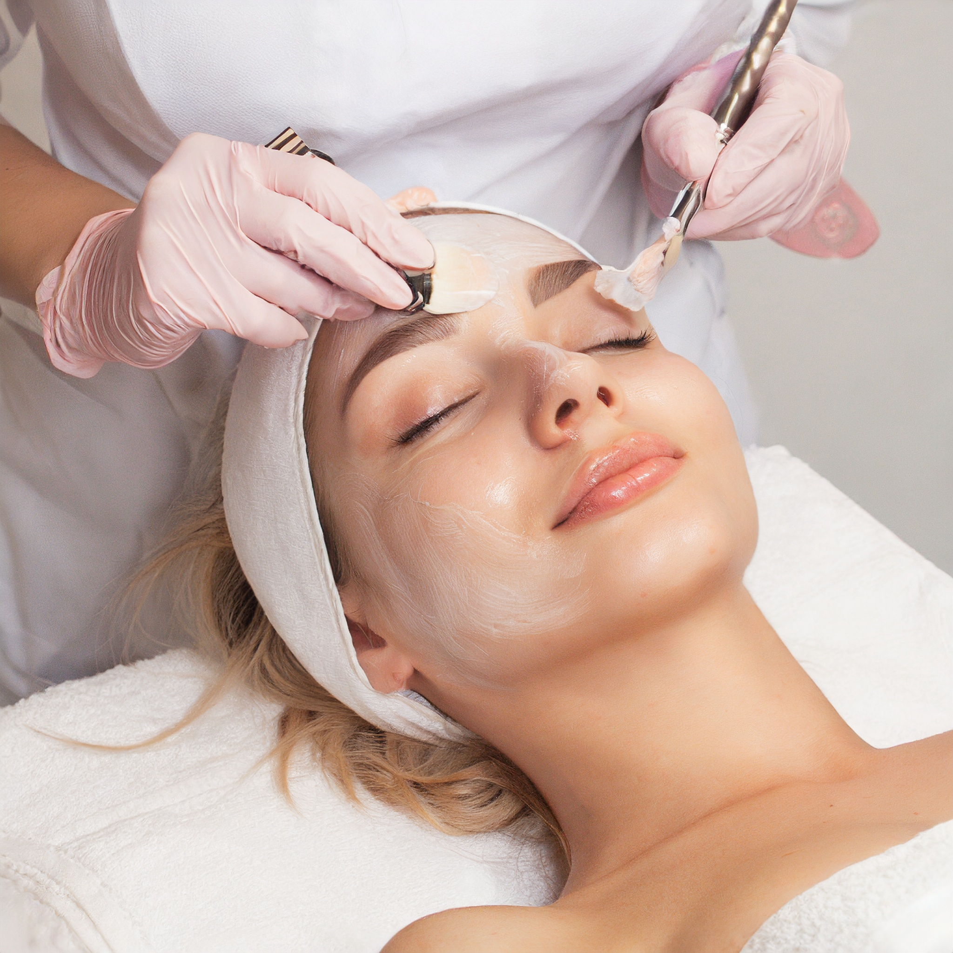

Nails, Esthetics, Permanent Make-up, Massage, Online Training
www.AdvancedEducator.net /www.permanentmakeupbydeb.com
208 N Wood St
Washington Il 61571
309-370-1629

Table of contents

2. Mission statement
2/3.Courses offered
3. Cost of educational programs at Advanced Educator School of Beauty
3. Statement of non-discrimination
3. Application and admissions requirements
4. License/ ownership
4. School staff
5. School calendar/dress code
5. Graduation requirements
5. Professionalism
5. School rules/ dress code/tardiness
6. Student Grievance procedure
6 Student Evaluation
6. Job placement
6. Student access to records
7 Refund policy /Transfer
8. Grading system
9. Course Objectives, grading system
10. Nails, Esthetics, Massage School Disclosures
10..Disclosures continues
11/12.. Accreditation / license status V/ A Student enrollment information
13. Nail Technology course outline
14. Esthetic Course outline

2022- 2027 School Catalog
Copyright August 31st 2015

Mission Statement
The primary goal of Advanced Educator School of Beauty is to develop in our students the highest possible degree of technical and professional competence. We train each of our students in the principles and practices of Nail Technology, Massage, Esthetics and Permanent Make up. At Advanced Educator School of Beauty, we are continually trying to provide each of our students with marketable skills and professional attitudes. Our objective is to help each student emphasize responsibility and gain social and technical skills necessary to be successful. Instruction takes place through a combination of theory class, practical work, clinical experience and internship. At the completion of the program the student is prepared for the State Board Exam and prepared to enter the Beauty profession.
Continued Education: Continued Education training is offered to licensed professionals in the beauty industry, through online courses, seminars, and private training.
Fees may change yearly
Your education is delivered through theory, practical and clinical work and supported using videos, demonstration, guest artists, and presentations. The instructors will monitor your work through practical work and written exams, making sure that you are well versed and prepared for the state board exam. These courses are offered to anyone over the age of 18 with an eight-grade education. (Potential students under 18 must have a parent’s signature to sign)
Cost of Education at Advanced Educator School of Beauty
The cost of each program is as follows:
Nail Technology $3,995.00 (8 week training )
Esthetics $5,995.00 (18 week training)
Massage Call for pricing
Permanent Make- up Training – Call for pricing - ( 100 hour training ) 40 hours in school
In person Continued Education is priced per class online classes are also available
Refresher courses in Nail Tech, Esthetics, are available
Also available Nail Tech Teacher, Esthetic Teacher Also offered - Cosmetology apprenticeship available --- after Jan 2027 please call for price and information
FINANCING NOW AVAIABLE!

* Not included in the school tuition – student uniform, (students professional liability insurance policy) at the time of internship/ apprenticeships, the state board exam fee.
Statement of non-discrimination
Advanced Educator School of Beauty Practices NO discrimination based on age, race, sex, color, creed, religion, disability, financial status, nationality, ethnic origin, or area of residence in any of its practices and policies on admissions, instruction, or graduation.
Applications and admissions
Advanced Educator School of Beauty requires that an applicant to the school must be at least 16 years of age or older. Any student under the age of 18 must have a parent or guardian signature.
3

Enrollment: These courses are offered only in the English language. A potential student must first fill out an application for enrollment. Pay application fee and/ or the balance of class that is required at the time of signing. A transcript and diploma will not be issued until class is finished in full ( Advanced Educator INC School of Beauty NOW offers a payment plan or a finance option) Please contact the school directly for more information. It is up to each individual student to fulfill their financial obligation to the school. Advanced Educator Inc School of Beauty. Students may pay by cash, check, money order, PayPal, credit card, easy pay, * pay pal credit cards, etc may be subject to additional charges, students may finance through the school’s finance program. Please contact the school for terms and conditions, which may be subject to additional fees and charges. Please make checks or money orders to Advanced Educator.
4

Advanced Educator School of Beauty / staff
The instructional staff are professionally carefully selected with several years of experience in each field of study. Each instructor holds a license of at least 40 years in their field of study, and 30 years of teaching experience. They are trained in a certain method to follow lesson plans. It is important to realize that we do carefully select our instructors to give our students the best education possible, as a student you (yourself) must also concentrate on developing good study habits, good attendance, practice, and dexterity. This is achievable through conscious practice.
If you have any questions do not be afraid to ask. If you need help, let your instructors know, that is why they are here. We know this will be an educational, fun, and rewarding program for everyone!
School Calendar
Classes are offered Jan through December and are ongoing excluding Major Holidays. * Enrollment into class must be no later than one week before the class begins. Permanent Make up classes are one on one training and are offered any time of year excluding major Holidays. All other classes will be scheduled as follows - Jan, April, August, December. The school may be closed to regular class schedules due to Continued Education seminars. (One day per month, three to four times per year) The school may also be closed during student’s enrollment for unsuspected reasons. In the event of inclement weather, school also may be closed. Students will be notified, and School closings will be posted on the bulletin board. The anticipated graduation date will be extended accordingly.
School will be closed for the following Holidays:
Memorial Day
July 4th Christmas Eve & Christmas Day through New Year’s Day
Labor Day Columbus Day Veterans Day Thanksgiving Day
Pmu course 40 Hours, Massage Course 600 Hours, Nail Technology 350 Hours, Esthetic Course 750 Hours DRESS CODE IS ALL BLACK UNIFORM (SCRUBS)--(BLACK COTHES ARE NOT ACCEPTABLE )* SHOES MUST ALSO BE BLACK WITH *CLOSED TOES UNIFORM MUST BE CLEAN AND PROFESSIONAL! --
Graduation requirements Each program offering a (diploma) will also require taking a State Board exam once the student has graduated from the school. The student will graduate with a diploma and a school transcript. The student must pass a written and practical exam with a score of at least 75% to graduate. All information needed to pass the exam will be covered during the class. The student to teacher ratio will never exceed 10 to1. (Permanent Make up training will be a student to teacher ratio of 1 to 1) Once graduated each student will then need to register for his/her state board exam to become fully licensed in their field of study. In a certification program, each student is fully certified upon graduation from the school. No further tests are needed to be qualified in their field of study. *If a student goes past the contract end date and fails to show up for the final exam the school will then charge a fee to take the exam. This fee is charged per exam, and this fee will be charged ( per class) if a student has taken multiple classes.
5

Professionalism Keep in mind you are training to become a professional, you must be a caring open-minded individual. You must use your knowledge to satisfy the needs and wants of every client. You must be able to put your own problems aside. You must be able to listen and observe, consult with the client, to understand the wants and needs of your client. Professionalism can be seen and felt. It is very important in your career.
School rules
Each student must clock in and sign a timecard.
No Student at any time shall show any disrespect in any manner being physical, verbal, nor with any gustier to anyone in the school.
Students must not text or call the staff after school hours to harass them. Students that use threatening language and profanity towards instructors and other students in any form, verbally, or through text/phone/email etc. WILL BE terminated. There is ZERO tolerance for this behavior, this will result in permanent termination.
Absentee/ Tardiness
If the student is absent or tardy the student must call the school.
Students must not miss or be tardy to class or more than 5 days during the program. 5 days of class (per course), missed (and or ) tardy will result in termination from the program. Excessive tardiness and absenteeism from class is not tolerated and this will result in termination.
* In an emergency the contract may be placed on (hold) ant the student may continue the course in the next session, or within four years of the initial start date. The student must keep the school informed of when he/she will be returning to school.
All students must maintain a grade point average of 75% or higher. Students will be put on an academic probation if a grade point average drops below 75% and will have one week to raise the grade before termination of the course.
NO food or drinks on the clinic floor.
NO CELL PHONES IN CLASS phones are restricted to the break room only!
Absolutely NO drugs or alcohol use on school grounds.
Smoking/ vaping etc. is allowed only in outside designated areas.
No open containers may be carried into the school.
**No one is allowed to loiter in the parking lot or on school grounds at any time / and (wait for students all day/ evening) while student is attending school. Students may be dropped off and picked up to and from school.
Dress code
Hair and make-up must be done each day.
Our uniform is ALL Black scrubs, with black closed-toed shoes must be worn each day you are attending school. The school does not provide uniforms.

6
Student grievance
Students who have a problem or grievance related to the operation of the school should use the following procedure to resolve the problem.
- Speak directly to the person(s) involved to resolve the issue.
- Speak to the director (owner). Who will render a written and oral decision within 3 school days.
Student Evaluations
Students must maintain both academic and attendance requirements to remain in the programs offered. Each student must maintain a 75% GPA or above to be considered making satisfactory progress. Each student will be evaluated every quarter.
Job Placement
Advanced Educator Inc. School of Beauty will prepare each student to successfully to work in the field they have studied. We prepare each student to work and operate their own business if desired. Advanced Educator Inc is available to help with job placement if needed but cannot guarantee job placement. Once the student has successfully completed their course of study, passed a written and final exam they will graduate with either a diploma and transcript, or certification (depending on the course) it is then up to each individual student to either go on to register for their state board exam or work in their field of study (Advanced Educator INC cannot guarantee passing grades for State Board exams.) We require that each student obtain their own liability insurance policy before starting internships. We only accept one of the two Beauty insurance companies Marine Agency, or Champ Beauty Ins –Each student is responsible for their own liability policy once they start training/ working. Each student /graduate is responsible for studying for the state board exam after graduation.
Student access to records
Additional copies from files receipts etc would be $15.00 per page copy. Copies of transcripts would be $25.00 per copy. (Original typed transcripts copies will now be $50.00 ) If a request from an outside agency asks for any student’s information, the information will not be released without the student’s written consent.
Refund policy
REFUND POLICY – NOTICE OF CANCELLATION Any monies due to the applicant or students shall be refunded within 30 days of official cancellation or withdrawal. Official cancellation or withdrawal shall occur earlier than the dates that:
An applicant is not accepted by the school. The applicant shall be entitled to a refund of all monies paid.
A student (or legal guardian) cancels his/her enrollment in writing within three business days of signing the enrollment agreement. In this case all monies collected by the school shall be refunded, regardless of whether the student has started classes. After cancellations, after three business days the school shall retain the application, book supply and any school equipment fees.
A student who withdraws or terminates a program prior to the course after 3 days of signing the contract, before starting the program (or) before completion of the program will be charged a cancellation or administrative fee of $150.00, including other charges the student and school may have incurred at the institution including (all kits and materials, books, products, unreturned school property, etc.) this will be calculated separately at the time of withdrawal. This refund policy applies to tuition and fees charged in the enrollment agreement. All total fees are identified in the catalog and in this enrollment agreement. A refund will not be issued for books, equipment, products already purchased by the school etc. A breakdown of school of supplies /tuition/ fees, expenses is available upon request, this may vary with the cost of supplies etc.
A student notifies the institution of his/her withdrawal in writing. / Signed
***If a student is utilizing the school finance program and drops out of school or does not finish the program the amount is still owed to the school based on the sliding scale below
7

A student on an approved leave of absence notifies the school that he/she will not be returning. The date of withdrawal shall be earlier of the date of expiration of the leave of absence or the date the student notifies the institution that the student will not be returning.
A student is expelled by the school. (Unofficial withdrawals will be determined by the institution by monitoring attendance at least every 30 days.)
In type 2, 3, 4 or 5, official cancellations or withdrawals, the cancellation date will be determined by the postmark on the written notification, or the date said notification is delivered to the school administrator or owner in person.
For students who enroll and begin classes but withdraw prior to course completion (three business days of signing the contract), the following schedule of tuition earned by the school applies. All refunds are based on scheduled hours: PERCENT OF SCHEDULED TIME TOTAL TUITION SCHOOL
ENROLLED TO TOTAL COURSE/PROGRAM SHALL RECEIVE/RETAIN
0.01% to 04.9% 20%
5% to 09.9% 30%
10% to 14.9% 40%
15% to 24.9% 45%
25% to 49.9% 70%
50% and over 100%

All refunds will be calculated based on the student’s last date of attendance. Any monies due to a student who withdraws shall be refunded within 30 days of a determination that a student has withdrawn, whether officially or unofficially. In the case of disabling illness or injury, death in the student's immediate family or other documented mitigating circumstances, a reasonable and fair refund settlement will be made. If permanently closed or no longer offering instruction after a student has enrolled, the school will provide a pro rata refund of tuition to the student OR provide course completion through a pre-arranged teaching agreement with another institution. If the course is canceled after a student's enrollment, the school will either provide a full refund of all monies paid or completion of the course later. If the course is canceled after a student's enrollment, the school will either provide a full refund of all monies paid or completion of the course later. If the course is cancelled after students have enrolled and instruction has begun, the school shall provide a pro-rate refund for all students transferring to another school based on the hours accepted by the receiving school OR provide completion of the course OR participate in a Teach-Out Agreement OR provide a full refund of all monies paid.
Students who withdraw or terminate prior to course completion are charged a cancellation or administrative fee of $150.00 in addition to any funds owed to the school. This refund policy applies to tuition and fees outlined in the enrollment agreement. Other miscellaneous charges that the student may have incurred at the institution (EG: extra kit materials, books, products, unreturned school property, course time etc.) will be calculated separately at the time of withdrawal. Any equipment, supplies, belongings etc that belongs to the student must be picked up within one week of leaving the school. The school will charge a $35.00 per month storage fee if the items are not picked up and will be discarded after one year. All fees are identified in the catalog and in this enrollment agreement. Students will also be charged for products, books, materials etc that were also taken and not returned to the school. A student must submit a written withdrawal to withdraw from any school program. If the contract goes past the contract end date the student will be charged a fee for each missed hour to finish the program as this is outlined in the contract.
For applicants who cancel enrollment or students who withdrew from enrollment a fair and equitable settlement will apply. The following policy will apply to all terminations for any reason, by either party, including student decision, course or program cancellation, or school closure. If a student withdraws after 3 days of signing a contract the school will retain the application fee and any items the school has purchased for the class, such as the books, supplies and equipment, the school will retain the monies spent on these items and the supplies. The student will not be refunded these fees.
The school does not guarantee the transferability of credits to another school, college, or university. Credits or coursework are not likely to transfer; any decision on the comparability, appropriateness and applicability of credit and whether credit should be accepted is the decision of the receiving institution.
8

Course objectives
Advanced Educator Inc School of Beauty offers comprehensive training in Nail Technology, Massage, Esthetics, Advanced Esthetics and Permanent Make up. Basic classes cannot be done online or correspondent. Some of our classes do offer part-time home study with the program. Home study may be offered during certain situations such as Covid closings. Etc Otherwise, these are hands-on classes and must be supervised and on site at our 3000 square foot facility. Advanced Educator Inc School of Beauty offers state-of-the-art equipment for Nail technology, Esthetics, Advanced Esthetics, Massage, and Permanent Make up. Each of these courses is designed to help the students achieve the highest possible degree of social, professional, and technical competence. With a structured curriculum, the school supplies the principles and practices of basic techniques through advanced techniques, continually focusing on skills that will make the student more marketable upon graduation. Practical instruction is done in conjunction with theory. This may at times include some mannequin work (depending on the course). Demonstrations, visual aids, live models, etc. You may have the same instructor for practical instruction as you have for theory. These courses do include a kit. The Nail Technology program is a minimum of 8 weeks or 350 hours- (diploma program) State Board exam required. The Massage program is a minimum 19 week- or 600 hour- (diploma program) State Board exam required. The Esthetics program is a minimum of a 18 week or 750 – (diploma program) State Board exam required. The Advanced Esthetics program is a minimum of 5 weeks 200 hours this is an advanced program and can only be done after the Basic Esthetics program, this is a (certificate program) No state Board exam required. The Permanent Make up program is a 100-hour Certificate program No State board exam required. (PMU is a one-on-one training) program. The Certificates are issued by the School Advanced Educator Inc School of Beauty. Nail Technology, Esthetics Advanced Esthetics, Massage, classes will not exceed a 10-1 teacher ratio.
*Continued Education courses are for licensed Professionals and continued education classes may be done online
Grading system -Each student is graded on his/her knowledge of the textbook, classroom theory, and practical/ clinical work throughout the program. A Written exam is given at the end of each chapter of study each phase of completion along with a final written and practical exam. Practical and clinical tasks are evaluated, and a progress report is done quarterly, on both practical and theory work. Students must maintain a 75% average or higher to continue in the graduate program. Students must show up on the scheduled final exam day to finish the course. Final exam days are set “per class” and cannot be rescheduled. Any student who fails to show up for the final exam “NO SHOW/ NO CALL” and misses the exam will be asked to call the school. Two missed final exams with a No call /no show are unacceptable and may lead to termination. (A fee will be required to take the final exam if the exam has been missed two times. ) Students wishing to return to the school to take a final exam and receive a transcript and diploma (after a long period of absence ) will need to pay any contract fees owed to the school. All students who successfully complete graduation will receive a transcript and diploma.
The following are guidelines for instructors to follow when determining the grade:
- 93-100% A
- 85-92% B
- 77-84% C
- 75-76% D
F-Below-75%
Written Exams
9
The number of correct answers is divided by the total number of questions to determine the grade. 75% is passing.
Practical and clinical
Sample of practical grading
1.Prepared, - the student comes to class prepared, with supplies, professional attitude, and greets the client.
2.Consult and arrange a plan – The student can consult with a client/instructor to prepare for a practical service.
3.Create and achieve desired result -The student can summarize step by step procedures to the instructor, and explain the products, implements they will use and why etc.
4. Complete- positive finish- the student asks questions to be sure the client is satisfied, finishes client card, and completes sanitation.
Enrollment-
Students must fill out an enrollment application and pay the enrolment fee and/ or balance of class at time of signing. The class must be paid in full before any transcripts or diplomas are issued. Advanced Educator does not have any type of finance program or payment plan. Each student must use their own resources for payment options, please note that the “ finance” button attached to the website is not affiliated with Advanced Educator school in any way.
Student to teacher ratio: -Nails, Massage, classes - 10-1-
Awards offered: Nails, Massage, and Esthetics – Diploma/transcript/
Campus Setting: Suburbs
Campus housing: no
Graduation rate for the last 12-month period was 100%
The number of students enrolled in the school in the last 12-month period -
Nails- 12 Massage 1- Esthetics -3 Permanent Makeup- 1
Students Completed or graduated from the programs-19
Placed in their field of study 19
Placed out of their field of study – 0
New Students still enrolled – 1
Reenrollments and transfers from other schools – 0
Withdrew /transferred from the program-0
Placed in a related field – 0
Placed out of the field -0
Not available for placement due to personal reasons-0
Not employeed-0
The number of students who took the state licensing exam in the last months was
Graduates obtained employment in their field of study after graduation
10

Accreditation status- Advanced Educator School of Beauty is approved to operate by the Business and Vocational Schools Division of the Illinois Board of Higher Education, Illinois Department of Financial and Professional Regulation, American Academy of Micropigmentation, and the Illinois Department of Public Health Contact Advanced Educator for additional questions 309-370-1629 email advanceded@hotmail.com
Complaints about this school may be registered with the Illinois Board of Higher Education, 1 N. Old State Capitol Plaza Suite 333, Springfield, Illinois 62701Contact Advanced Educator for additional questions. 309-370-1629 email advanceded@hotmail.net Advanced Educator School of Beauty Is not accredited by a US Department of education, Advanced Educator School of Beauty is a Fully licensed School in the State of Illinois
11
In a case in which an individual is unable to meet a financial obligation to an educational institution due to the delayed disbursement of a payment to be provided by the Secretary under chapter 31 or 33 of such title and the amount of such disbursement is less than anticipated, nothing in section 3679(e) of such title, as added by subsection (a), shall be construed to prohibit an educational institution from requiring additional payment or imposing a fee for the amount that is the difference between the amount of the financial obligation and the amount of the disbursement Pro Rata Refund Policy All tuition, instructional charges, fees (including registration fee more than $10)for veterans is subject to the following pro-rata refund policy: Percentage of days in class completed by student Percentage of tuition, instructional
12

Basic Nail Technology course outline
- Nail Technology Class is a 350 hour (total course) these hours may be clocked through in school hours, partial online study, and salon internship. (Classes meet at the school 2 days a week) For part time classes. Once the student has accumulated the total hours required, passing all the written and practical curriculum required by the state a transcript will be issued by the school. The student will then be able to apply for the Illinois State Board exam, once the student passes the State Board exam, he/she may become a Licensed Nail Technician. (the State Board Exam fee is not included in the cost of the school program).
Course covers;
- e- book and state board exam review book
- All types of Nail applications, Hard Gel, Soft Gel, Acrylic tips, Acrylic Sculpture, Hard Gel Sculptured nail, Apres GelX
- Ares Gel-X Professional Certificate (Normally offered at $600 and only to Licensed Nail Techs but is included in our tuition)
- Proper Safety and Sanitation for the salon
- Manicure Basic and Spa
- Pedicure Basic and Spa
- Acrylic / gel & Toe nail application
- UV/LED Builder
- ALL Gels
- E-file
- Nail/Skin Disorders
- Tips/ Application Forms
- Wraps
- No-Chip / Poly Gel / Dip Powder
- Structured Manicure / Advanced Gel Manicures
- Hands on Nail art class
- 3D Acrylic / 3D Gel art!
- Marble/Ombre
- Air Brush
- Cat Eyes, Spider Gel Art, Pigment Art, Foil Art, Blooming Gel Art
- Stamp Art, Stone, Gems, Aquarium nails all nail art!
- Preps for Chapter tests weekly
- Internships in a salon
Prep for School Final Exam / Prep for State Exam
- Business Prep Class
- Social Media Marketing
- Salon Management
- State required classes needed - Sexual Harassment, Domestic Violence & “The Skinny on Skin” all classes needed to enter the beauty industry
- ALL CLASS SIZES ARE SMALL -are 6 people or less than -allowing STUDENTS TO GET INDIVULIZED ATTENTION!

13

Basic Esthetic Class outline
The Esthetic Class is a (750 hour total) course these hours can be clocked through in school hours, partial online study, and salon internship. Once the student has completed the total amount of hours required, passing all the curriculum required by the state a transcript will be issued by the school. The student will then be able to apply for the Illinois State Board exam, once the student passes the State Board exam , he/she may become a Licensed Esthetician. ( the Sate Board Exam fee is not included in the cost of the school program).
Course includes; E-book and state board exam review book
*Anatomy and Physiology
*Diseases and Disorders of the Skin
*Cosmetic Chemistry Ingredients and Product Knowledge
*Sterilization, Sanitation, and Bacteriology
*Safety and Sanitation

*Basic Facials and Facial Massages
*Application of Makeup and Sales Product Knowledge
*Basics of Chemistry, Electricity and introduction to medical Aesthetics Equipment
*Hair Removal: Depilation, Waxing and Sugaring
*Eyelash and Eyebrow Extension
*Eyelash lift /Eyebrow / Lash Tinting
* Brow lamination
* Microdermabrasion
*Dermaplaning
* HydraFacial
*Clinical Practice, Record Keeping, and Treatment Procedures
*Career Planning and The Skin Care Business
* Salon Business
*Management, Laws, Communication, and Ethics

* Business Class

Prep for weekly chapter tests
Prep for State Board Exam
All state required classes included in this class to apply for the State Board exam
- Domestic Violence, Sexual Harassment, “The Skinny on Skin”
- Business Prep Class
ALL CLASS SIZES ARE SMALL – (6 people or less than) -allowing STUDENTS TO GET INDIVULIZED ATTENTION!
14

